فصل سوم

**مثال در مورد عملگرهای مقایسه ای**

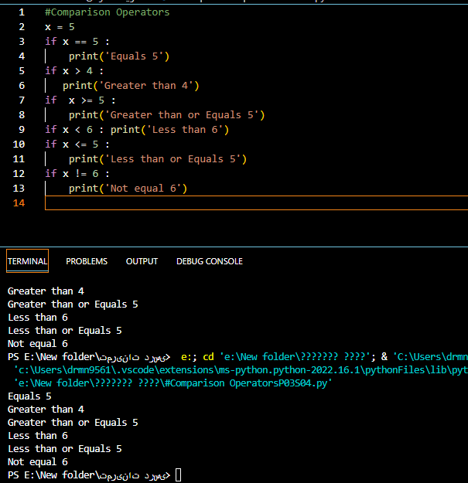

Comparison OperatorsP03S04#

**تصمیمات یک جانبه (One-Way Decisions)**

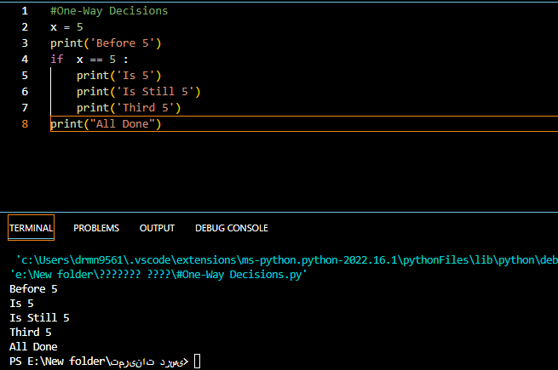

One-Way Decisions #

**مثال درمورد تصمیمات تو در تو(Nested Decisions)**

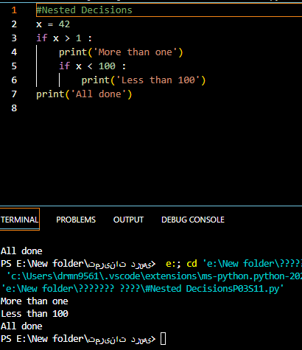

Nested DecisionsP03S11#

**مثال درخصوص تصمیمات دو طرفه (Two-way Decisions)**

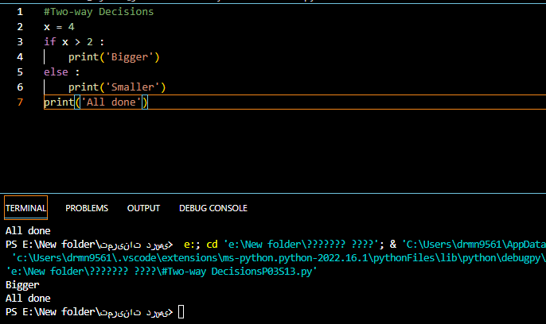

Two-way DecisionsP03S13#

**مثال درخصوص تصمیمات چند طرفه (Multi-way)**

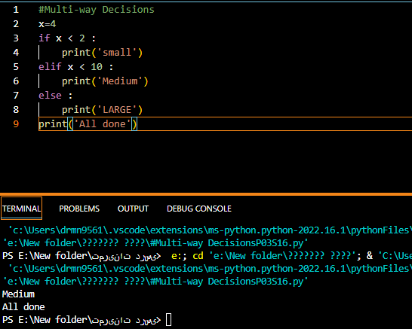

Multi-way DecisionsP03S16#

**تمرین 1 فصل 3 :**

**Rewrite your pay computation to give the employee 1.5 times the hourly rate for hours worked above 40 hours**

**Enter Hours: 45**

**Enter Rate: 10**

**Pay: 475.0**

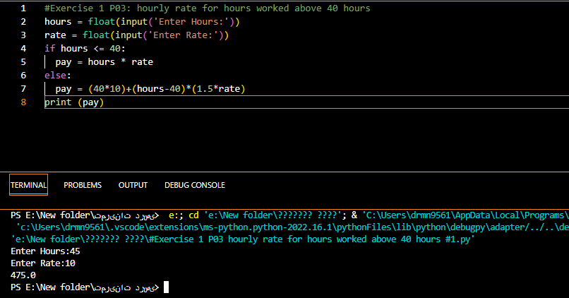

Exercise 1 P03 hourly rate for hours worked above 40 hours #1#

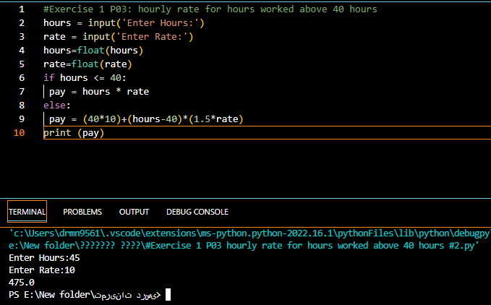

Exercise 1 P03 hourly rate for hours worked above 40 hours #2#

**تمرین 2 فصل 3 :**

**Rewrite your pay program using try and except so that your program handles non-numeric input gracefully**

Enter Hours: 20

Enter Rate: nine

Error, please enter numeric input

Enter Hours: forty

Error, please enter numeric input

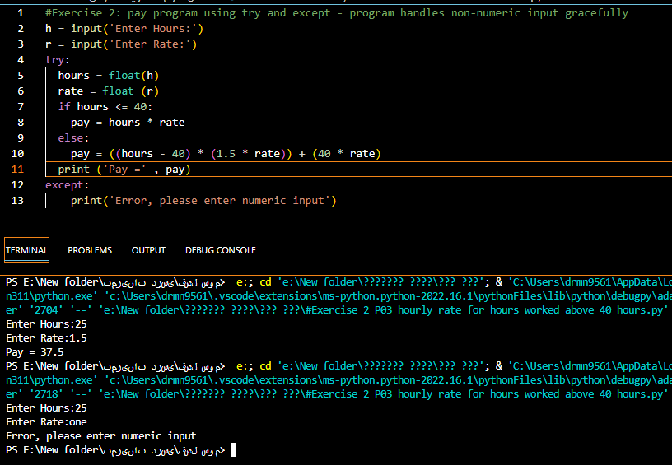

Exercise 2 P03 hourly rate for hours worked above 40 hours #